**CHAPTER - 1**

**FASHION HAVEN**

**INTRODUCTION**

**This guide represents a selection of the many resources in the Library of Congress that may be useful for the study of the business aspects of fashion. It includes all aspects of fashion - clothes, shoes, bags, accessories. It also includes suggested subject headings which interested researchers may select to link directly to our online catalog in order to search for additional materials on this topic.**

**Also, since keeping up with the fast pace of change is an ongoing process in the "here today, gone tomorrow" fashion industry, we have have included a number of related external resources. Using traditional trade literature and web portals, as well as reports from research groups is essential as a way to find the more general articles and reports but it may be even more important to find reports and articles that look at a particular segment, niche market, situation, or trend so we have included a few links to various web sites that may also be of interest.**

**Fashion is a popular aesthetic expression. Most Noteworthy, it is something that is in vogue. Fashion appears in clothing, footwear, accessories, makeup, hairstyles, lifestyle, and body proportions. Furthermore, Fashion is an industry-supported expression. In the contemporary world, people take fashion very seriously**.

## Purpose of fashion haven

* How the things are to be portrayed. Fashion promotes social changes from time to time and also respects traditions and customs in society
* Fashion encourages to modify or amend all those customs that are rigid and have no relevancy
* Fashion in itself means the way you want to wrap yourself up, which doesn’t have to be clothing or materialistic things.
* It is the way you portray things about yourself or others and rather a vision to look up to.
* You can have the sense of fashion in eating, sleeping, presenting yourself, talking. So simply, fashion is a sense of understanding

CHAPTER-2

EMPATHY MAP:

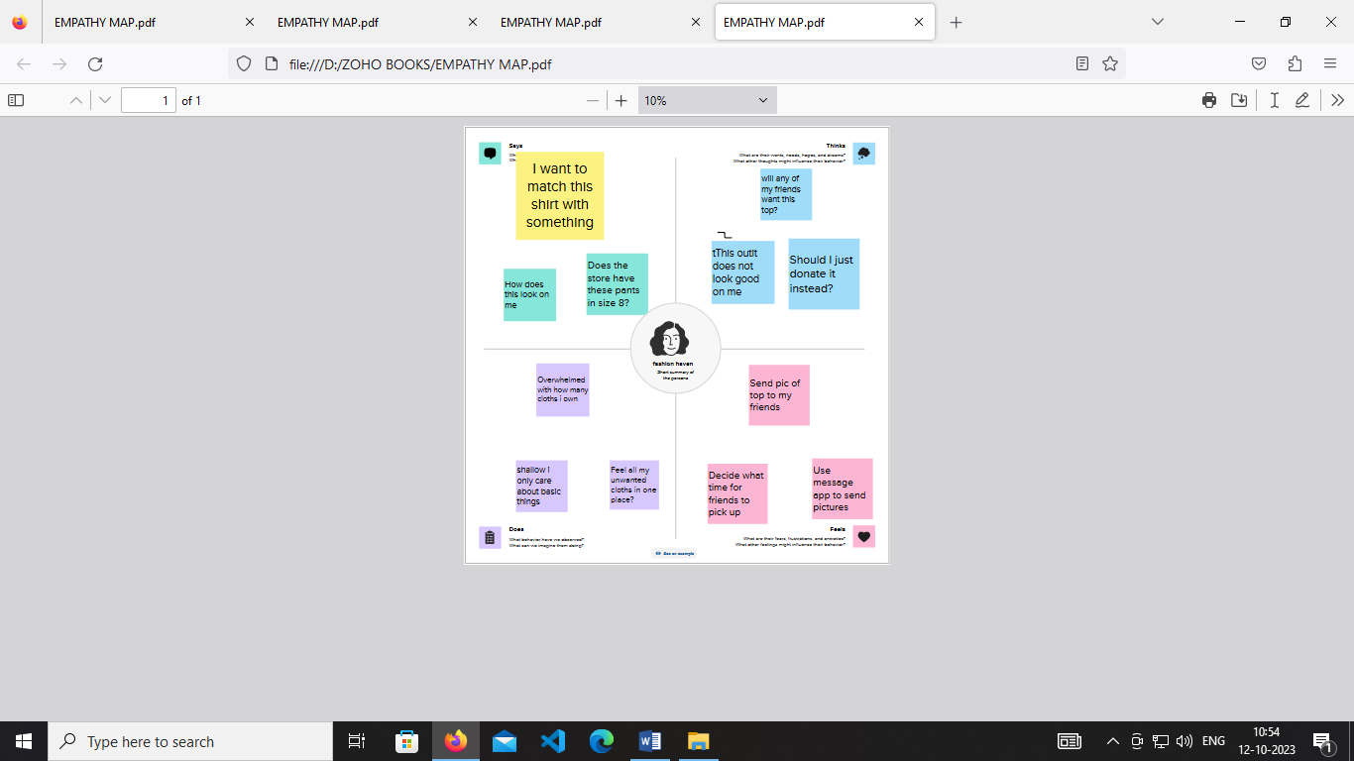

BRAINSTORMING:

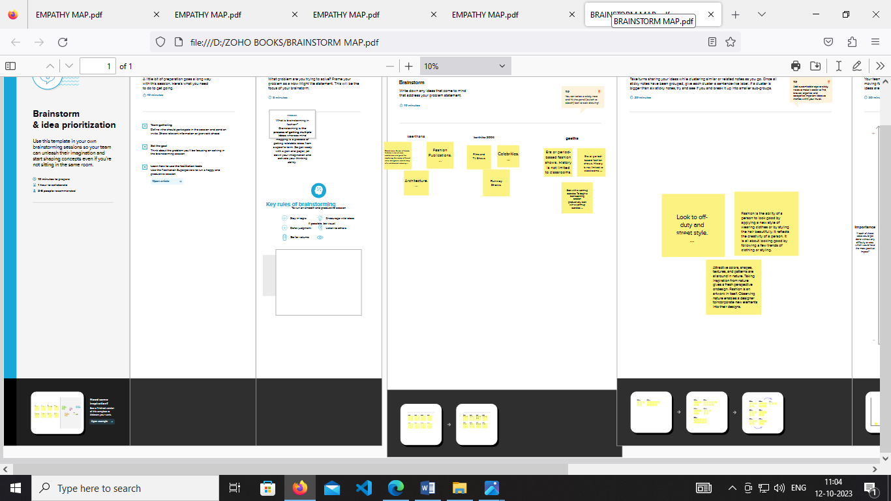

CHAPTER-3





CHAPTER-4

**ADVANTAGES OF FASHION HAVEN**

* Fashion makes you confident: When you dress up elegantly it makes you more confident, everyone wants to associate with you.
* arrt gives you a definition: For some people there's a particular way they are known to dress even without showing their face you already know who dresses like that. Eg, ayra star
* It gives a good sense of humor.
* Fashion is a big part of my personal identity and culture. For culture, Many groups of people used clothing to symbolize important things.
* Now it is a huge part of the economy, It is worth well over 3 trillion and currently grows each day.
* It even is the 2nd biggest economy trade industry. Not to mention the industry employs over 57 million people, In developing countries. Of whom around 80% are women!
* Also expressing yourself through clothing can make you stand out and make you feel better about oneself. Overall, Fashion itself and the industry is game-changing.

DISADVANTAGES OF FASHION HAVEN

* You’re assuming that having **ONE** disadvantage completely negates any possibility of a character to be maintained by evolution
* That should kill their owners and yet remain well represented within the gene pool.
* For example, one could say that peacocks are complete idiots who should go extinct real soon because the male’s tail is a dead weight that threatens their lives on a daily basis (in wild conditions)
* Not saying that the same happens with leopard spotting on horses, but just to make it clear: **having a catch doesn’t mean the animal is doomed to go extinct,** as long as the advantage of its characters outweigh the disadvantages.
* There is difference in fashion and trend. Trend is something which is already running in market and people following it

.

* and how can someone create something disadvantageous thing for own. Fashion is something which create by own
* Fashion gives you livelyness and makes you creative. Improve your personality and stand you out from the crowd.
* So how can someone tell you disadvantages of fashion.

CHAPTER-5

**APPLICATION OF FASHION HAVEN:**

If we want to change something, we need to start with ourselves and our own beliefs. Our own moral compass must repel the cheap throw-away/ single-use mindset and opt to choose something else. It may not place you on a throne and be pronounced Khaleesi (or Khal), but maybe you can be the Jon Snow of the world and fight for something larger than yourself. Something for everyone. Something for our children who haven’t been born yet. My niece just turned one and it pains me to think that she may not see some of the beauty in this world that you and I have been fortunate to see.

If we make changes to how we buy, the demand will drive the manufacturers to change, then the advertisers will jump on and feed us with the ‘desire to buy mindfully’.

So to be the hero, you need to know the problems”.

# THE PROBLEM:

# Labour and Environmental conditions

Children working in factories, long hours and low wages, lack of schooling, toxic environments. In Uzbekistan children are taken out of school to harvest cotton. Girls are even being given hormones to reduce menstruation ‘because it makes them less productive’. Here’s a video on asking kids in Australia about kids [working in factories](https://www.youtube.com/watch?v=01Xsz_IpiqM). Not much of a childhood right? Similarly, adult workers exploited with long hours, low wages and toxic environments. In Bangladesh, wages can be as low as [£56 a month](http://www.scmp.com/magazines/post-magazine/article/1970431/true-cost-your-cheap-clothes-slave-wages-bangladesh-factory).

# Land Depletion

Agriculture is considered to have the most impact on deforestation worldwide. Land is cleared for livestock for food and also for leather. The Rainforest Action Network estimates that 120 million trees are logged every year to make clothing, an area expected to increase since the production of dissolving pulp — the base material for **viscose, Rayon and modal**– could double by 2050. [(Greenpeace report)](https://www.greenpeace.org/international/Global/international/briefings/toxics/2016/Fact-Sheet-Timeout-for-fast-fashion.pdf).

One of the main challenges which has been ignored is the quality of our Soils. Soils are complex mixtures of minerals, water, air, organic matter, and countless organisms that are the decaying remains of once-living things. It is the “skin of the earth.” Soil is capable of supporting plant life and is vital to life on earth. [(Soilsf4kids)](http://www.soils4kids.org/about). The more we deplete the soils of nutrients, the less land will be available to grow an ever-increasing food supply. Do you fancy going back to the days of the world wars and food rationing?

**CHAPTER-6**

**CONCLUSION FOR FASHION HAVEN**

Fashion can be overlooked and downplayed quite often. Fashion is so much more than just throwing on a pair of pants with a shirt. Fashion and personal style means something to people. Its a way of expressing who someone is or to prove themselves to others, its a womans vulnerability, style is something that is someones own and makes a person feel unique and individual. For as long as time can tell fashion has played a huge role in the world and its something people will never not need. Fashion is constantly evolving and changing and with each era of life comes a new style and trends. Fashion patterns travel every which way; then a general public's esteems are built up and developing trademark to their convictions and culture. Fashion is recently not a driven anticipated picture of a reinterpreted decent old incentive to satisfy some capacity or motivation alike yet rather a suggestive and invigorating idea sufficiently commendable to be depicted for society's gratefulness that makes us significantly more intuitive. As an outflow of their emotions the present youth attempt to decipher design inclines and embrace the garments style that suits their esteem and attributes. It is stream crosswise over hypothesis where the draw of stylish experience has offered ascend to regular design and psychological engagement. The accomplishment of the design drift lies in the way the general public deciphers the form slant and judges it. Consequently the effect

CHAPTER-7

**FUTURE SCOPE OF FASHION HAVEN**

Iare planning to follow your heart and make a career in the fashion industry this is the best time. It is not because you are following your intuition but undoubtedly you are building your career in the most popular and fast-growing industry in India. The fashion industry has reached its peak and advancing further to scale up and up.

On the other hand, the mounting cut-throat competition and immense challenges are an undeniable part of this fashion industry. The observance and practice of fashion designing can be noticed since the time of Egypt Pharaoh. It will continue to an indefinite time till the trace of humanity on the planet earth exists because the innate feeling of ‘look good and feel good’ in human beings cannot diminish. The vast[*scope of fashion designing*](https://jdinstituteoffashiontechnology.com/fashion-designing-courses) cannot restrict to India or one country. It expands beyond the borders. But first, it’s important to understand the future scope of fashion designing in India. Some crucial factors play a significant role to decide its scope. So let’s explore the key factors further-

Recruitment professionals and agencies are constantly looking for the right candidates for a [*career in fashion designing*.](https://jdinstituteoffashiontechnology.com/fashion-designing-courses) However, passion, hard work and a conscious effort to understand and update the latest trends in the fashion industry are imperative for fashion designers. Many Fashion houses and boutiques run by top fashion designers such as Manish Malhotra, Neeta Lulla, Ritu Beri, Sandeep Khosla, Ritu Kumar, Rohit Bal, Sabyasachi Mukherjee, Tarun Tahiliani and so on hire skilled and talented designers for their studios. Many big [*garment manufacturer and textile export*](https://jdinstituteoffashiontechnology.com/govt-recognised-courses/garment-manufacturing-fashion-design/) houses appoint in-house designers. Textile and fabric manufacturing units also assign designers for the work. Exclusive and branded fashion showrooms sign up the designers for the designing and detailing task.

### 4. **Demand and Supply**

Indian fashion designing is attracting a lot of popularity abroad because of the excellent craftsmanship and cheap labour. Many top Indian designers and fashion houses are now catering to this mounting international demand for quality fashion designer products and accessories. In addition to that, the demand for Indian garments, textile, fabric print, pattern, designer saris are also in huge demand.

Still have queries or doubts about the scope and careers of fashion designing in India, connect with the experts to learn more.

## The Bright Future of Fashion Designing in India

India has always been known for its rich textile heritage and intricate craftsmanship, and the fashion industry in the country has seen a significant boom in recent years. With the rise of e-commerce and social media, the future of fashion designing in India looks brighter than ever before.

One of the main factors driving the growth of the fashion industry in India is the increasing purchasing power of the middle class